26th June 2019

**Miss Yokohama joins Motorsport experience**

The delightful Miss Yokohama 2018/19 Milena Crusi, delighted many motorsport fans during the recently held WTCR Race of Germany during the 24hr race weekend.

Milena flew in especially for the occasion and to support promotional activities. She joined the Grid girls before the racing and had the opportunity to chat with many team representatives, drivers and members of the public who were very keen to have photos taken with Miss Yokohama.

Miss Yokohama is chosen yearly by the Swiss subsidiary of YOKOHAMA Europe. The elected Miss Yokohama then embarks on a diverse programme of promotional activities which include supporting and attending the Geneva Motor Show, as well as many other national events in Switzerland and this time attended also the WTCR Race of Germany, of which YOKOHAMA is the exclusive Tyre supplier.

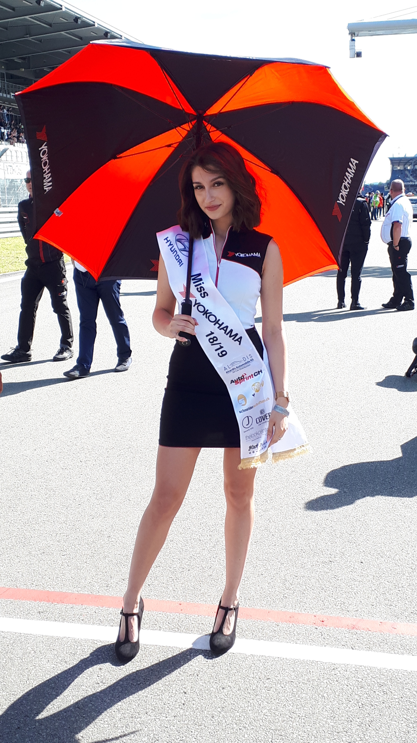

*Miss Yokohama Milena Crusi Photo Timo Elsesser*

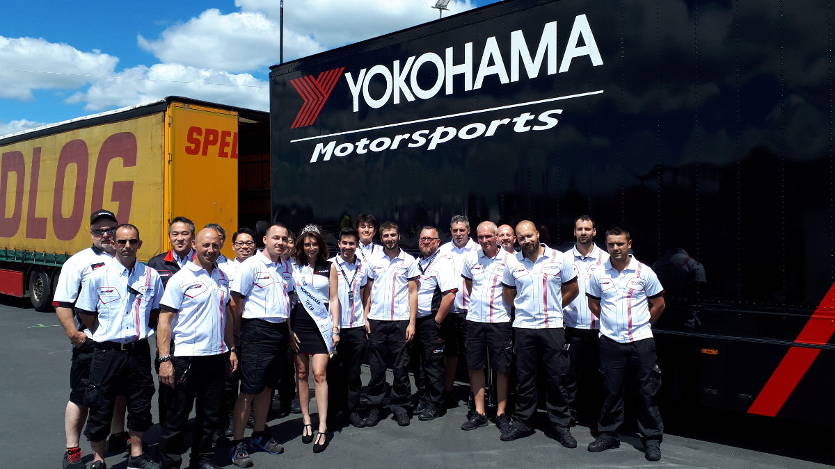

*Miss Yokohama with MS Team members*